Russell Bjella

ASEN 6008 – Lab 1 Intro

1 February 2017

**A. Simulating an orbit**

1. 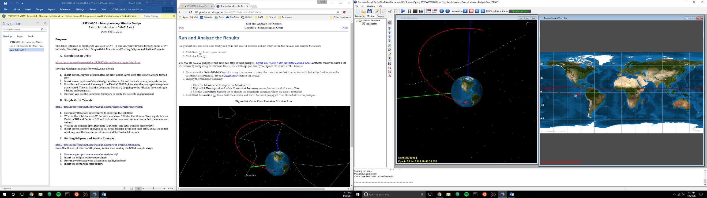(and (2)) 3D and ground track views below, periapsis is indicated by the position of “Sat” on the right-hand side of the image.
2. Command Summary:

****** Changes made to the mission will not be reflected ******

****** in the data displayed until the mission is rerun ******

Propagate Command: Propagate1

Spacecraft : Sat

Coordinate System: EarthMJ2000Eq

Time System Gregorian Modified Julian

----------------------------------------------------------------------

UTC Epoch: 23 Jul 2014 20:48:34.393 26862.3670647284

TAI Epoch: 23 Jul 2014 20:49:09.393 26862.3674698210

TT Epoch: 23 Jul 2014 20:49:41.577 26862.3678423210

TDB Epoch: 23 Jul 2014 20:49:41.576 26862.3678423151

Cartesian State Keplerian State

--------------------------- --------------------------------

X = -7466.6017206564 km SMA = 83938.555279821 km

Y = 4104.8939594891 km ECC = 0.8975373278076

Z = -1170.2503328836 km INC = 12.430660360941 deg

VX = -4.2651116225787 km/sec RAAN = 292.65758666753 deg

VY = -8.2039635778501 km/sec AOP = 219.20594194467 deg

VZ = -1.5642043869574 km/sec TA = 360.00000000000 deg

MA = 360.00000000000 deg

EA = 360.00000000000 deg

Spherical State Other Orbit Data

--------------------------- --------------------------------

RMAG = 8600.5686739409 km Mean Motion = 2.596131297e-005 deg/sec

RA = 151.19944062694 deg Orbit Energy = -2.3743584826497 km^2/s^2

DEC = -7.8203020255811 deg C3 = -4.7487169652993 km^2/s^2

VMAG = 9.3777892332854 km/s Semilatus Rectum = 16319.900099176 km

AZI = 99.692752055627 deg Angular Momentum = 80654.320310615 km^2/s

VFPA = 90.000000035600 deg Beta Angle = 21.714871859344 deg

RAV = -117.46921192606 deg Periapsis Altitude = 2222.4323739409 km

DECV = -9.6017488421297 deg VelPeriapsis = 9.3777892332854 km/s

VelApoapsis = 0.5063791526093 km/s

Orbit Period = 242021.09174444 s

Planetodetic Properties

---------------------------

LST = 151.38083007540 deg

MHA = 253.65146344970 deg

Latitude = -7.9323313269337 deg

Longitude = -102.27063337430 deg

Altitude = 2222.8369807829 km

Spacecraft Properties

------------------------------

Cd = 2.200000

Drag area = 15.00000 m^2

Cr = 1.800000

Reflective (SRP) area = 1.000000 m^2

Dry mass = 850.00000000000 kg

Total mass = 850.00000000000 kg

1. It can be verified that the satellite is at periapsis at the stop condition by checking the true anomaly under “Keplerian State” in the command summary. The value above is 360 degrees, so the satellite is at periapsis at the end of the simulation.

**B. Simple Orbit Transfer**

1. The targeter took 7 iterations to converge.
2. TOI: 2.2402692107499 km/s

GOI: 1.4406428582523 km/s

1. Transfer start time: 01 Jan 2000 13:12:30.729 UTC

Transfer stop time: 01 Jan 2000 18:32:14.278

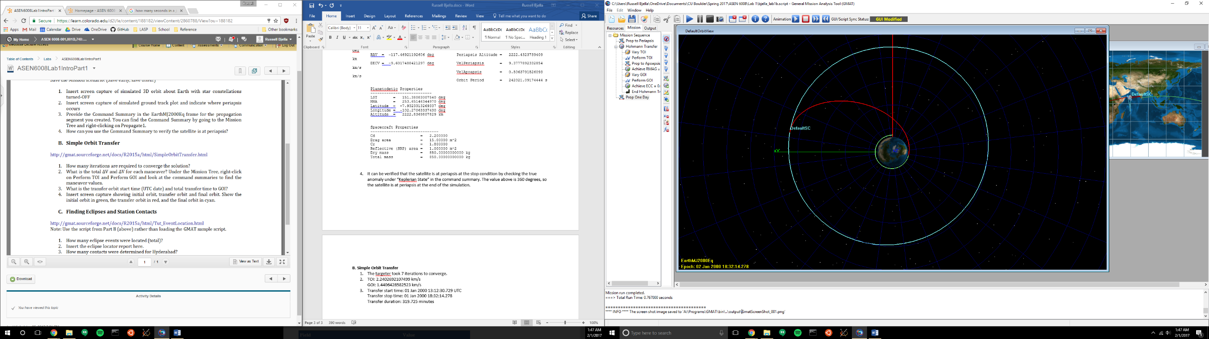Transfer duration: 319.725 minutes

1. Initial, transfer, and final orbit.

**C. Finding eclipses and station contacts**

1. Three eclipses were found.
2. Eclipse report

Spacecraft: DefaultSC

Start Time (UTC) Stop Time (UTC) Duration (s) Occ Body Type Event Number Total Duration (s)

01 Jan 2000 12:10:05.136 01 Jan 2000 12:10:15.516 10.379568336 Earth Penumbra 1 2105.5343751

01 Jan 2000 12:10:15.516 01 Jan 2000 12:45:00.414 2084.8983078 Earth Umbra 1 2105.5343751

01 Jan 2000 12:45:00.414 01 Jan 2000 12:45:10.670 10.256498947 Earth Penumbra 1 2105.5343751

Number of individual events : 3

Number of total events : 1

Maximum duration (s) : 2105.5343751

Maximum duration at the 1st eclipse.

1. Two contacts were located for Hyderabad
2. Contact report

Target: DefaultSC

Observer: Hyderabad

Start Time (UTC) Stop Time (UTC) Duration (s)

01 Jan 2000 11:59:28.000 01 Jan 2000 12:05:58.248 390.24814353

01 Jan 2000 13:34:20.816 02 Jan 2000 18:32:14.157 104273.34070

Number of events : 2